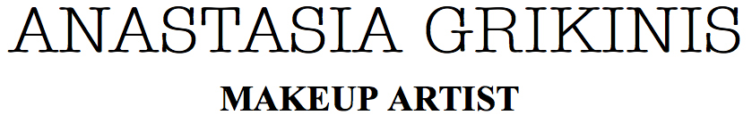
Date of wedding..............................Time......................................
Brides name..........................................................................................................
Address.................................................................................................................
Telephone..........................................email..........................................................
Address of wedding .............................................................................................
..........................................................................postcode.....................................
Bridal makeup.................................................................................................
Bridesmaid makeup.....................................................................................
Mother of bride makeup..............................................................................
Mother of Groom makeup...........................................................................
Others makeup.............................................................................................
Wedding suppliers
Dress
Florist
Hairstylist
Photographer
A non refundable part payment of £80 is required to hold your date. Trials to be paid for on the day of trial. There will be no refunds on cancelation.
Bank transfer HSBC s/c 40-24-11 ac/n 11678167
cash made payable to Anastassia Grikinis
Photos taken may be used for my website and portfolio.
SIGNATURE...............................................................................DATE......................................
www.anastasiamua.co.uk

